REPORT OF THE DISTRIBUTION OF PALLIATIVES BY NEW INITIATIVE FOR SOCIAL DEEVELOPMENT (NISD) WITH THE SUPPORT OF VICTIMS SUPPORT FUND (VSF)
BACKGROUND:
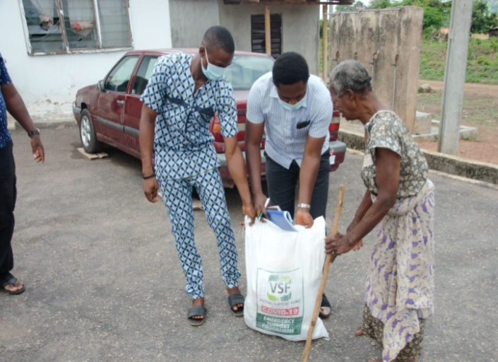
Worried by the negative impacts COVID-19 has had on the social economic lives of indigents Ekiti State residents, the Nigeria Foundation for the Support of Victims of Terrorism (Victims Support Fund) VSF supported New Initiative for Social Development (NISD) along with other NGOs in the Ekiti State to identify, distribute and monitor the disbursement of palliatives to selected individuals (vulnerable). The purpose of the grant by (VSF) was to form a working relationship with the Grantee (NISD) in furtherance of VSF 2020 Covid-19 Response Programme. NISD transported and distributed the food, hygiene and safety items to vulnerable households in Ijelu Ekiti, Oye LGA and in selected communities in Ado Ekiti LGA as obligated in the contract and ensured that community leaders as well as leaders of faith in areas where the disbursement are to be made are kept in the know. The full pack which contains one bag of 10kg rice, one bag of 10kg beans, one bag of 10kg garri, 4Litre of vegetable oil and two 2kg of salt sachets were warmly received by the people. Also, personal protective equipments PPE such as hand-sanitizers, and nose-masks were given out. In all one hundred and thirty seven (137) palliatives containing the items listed above were handed over to New Initiative for Social Development and were distributed accordingly.
Figure 1: A beneficiary being attended to at Ijelu Ekiti

LOGISTICS:
NISD hired the service of a professional photographer who turned out quality pictures and also engaged a driver whose van took delivery of the palliatives and also conveyed the items to selected communities for onward dispatch and distribution. Both photographer and driver worked for the number of days it took to deliver the palliatives to identified beneficiaries. NISD also ensured that common data base of beneficiaries were collated and made it mandatory for beneficiaries to register their details on a registration form provided for verification for subsequent use. Adhering strictly to humanitarian principles and confidentiality NISD ensured that the details of beneficiaries are kept from public access.

RATIONALE BEHIND BENEFICARIES/COMMUNITY SELECTION:
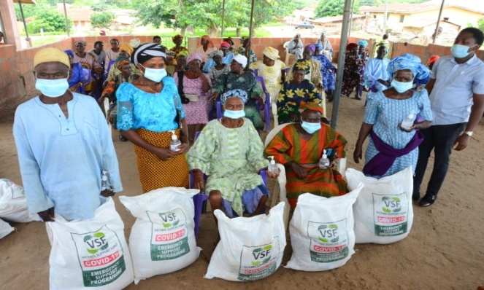
Oye and Ado LGAs were selected by NISD and the Special Assistant to the Governor on Civil Society Matters Mr Abiodun Oyeleye supervised the process. Ijelu Ekiti was chosen as the benefitting community in Oye LGA for the first batch of distribution for reasons largely connected to the pitiable state of the community. The community being a remote one is completely cut off due to bad roads network. Residents of Ijelu Ekiti who are mostly farmers find it difficult to convey their produce from the farm to market places not to talk of moving them to bigger towns. Covid-19 has further aggravated the sufferings of the communities who already suffer from absence of basic infrastructures and social amenities. Affirming the claim of a community in urgent need of support, the Honorable Councilor George representing the community said that compiling the list of vulnerable in the community is a herculean task considering the fact that almost all the residents in the community ar vulnerable and have one social deficiency or the other.
Figure 2: Cross Sections of beneficiaries at Ijelu Ekiti

DISTRIBUTION MECHANISM:
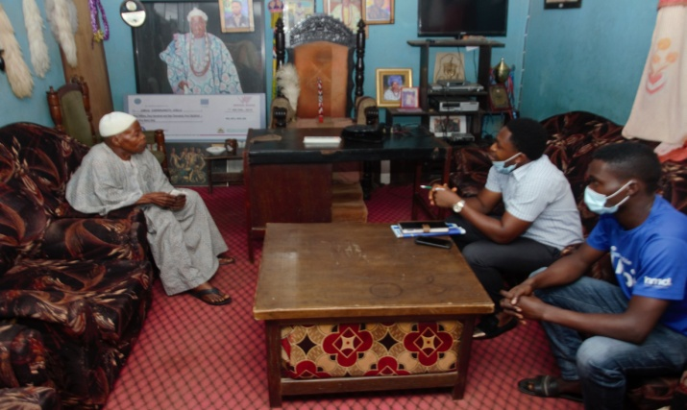
On June 6th 2020, NISD distributed Forty (40) food bags containing the listed contents above to selected beneficiaries in Ijelu Ekiti. The beneficiaries mostly aged, widows, people living with disabilities and other less privileged were considered the poorest of the poor in the community. On arrival we paid homage to the traditional ruler King Omotoyinbo Ajayi The king applauded the gesture of VSF and said the support will go a long way to alleviating the sufferings of his people. While confirming the names of the beneficiaries as actually being poor or need, the king throws his weight behind it and said the list reflect the actual state of his people’s vulnerability. Beneficiaries some of which are already gathered in a prominent church hall in the community cannot hide their joy when the distribution took off. NISD ensured that VSF Covid-19 Task force distribution list containing verifiable contacts and details of beneficiaries were adhered to and deployed for use.
Figure 3: With the traditional ruler of Ijelu Ekiti Oba Omotoyinbo Ajayi

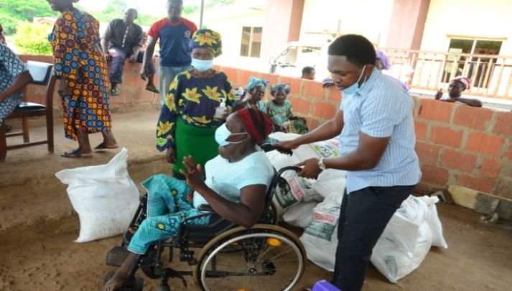
On June 7th 2020, NISD wrapped up the distribution of palliatives to identified beneficiaries in Ijelu Ekiti, Oye LGA. Another forty (40) set of palliatives were given out courtesy of VSF. This last batch of palliatives targets the very aged, the home sick and those living with disabilities. The beneficiaries are already gathered in the venue with their care givers; children and wards to help them covey their palliatives. Addressing the already arranged beneficiaries, NISD Programs Head and Acting Executive Director Mr Ogunlade Olamide Martins told them that the support received is from Victim Support Fund, an NGO that is committed to helping disadvantaged class and not from Government as against the insinuations from the public. He however said that Government provided access and the enabling environment for the engagement. Buttressing his words, Mr Oyeleye Abiodun said Ekiti State government is aware of the support being provided by VSF and that it was hugely welcomed. He told the beneficiaries that he is mandated from the government to monitor the process. In all, eighty (80) palliatives were distributed in Ijelu Community, in Oye LGA of Ekiti State. Pictures are attached with this report.
Figure 4: A beneficiary being assisted to collect her palliative at Ijelu Ekiti.
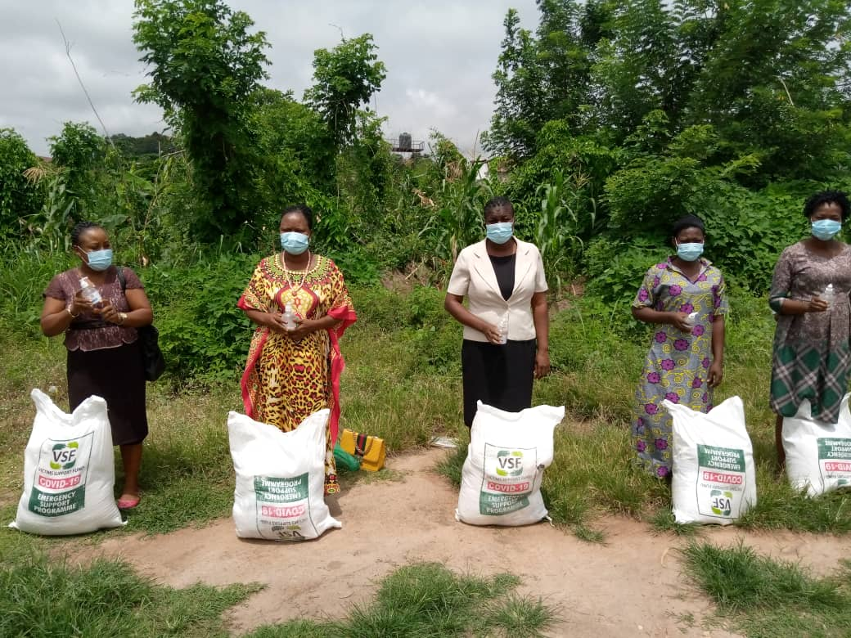
On June 17th, 2020 NISD distributed the last batch of fifty seven (57) palliative to selected beneficiaries in Ado Ekiti. The beneficiaries were mainly residents of Iso, a sub-community within Ado Ekiti. Identified beneficiaries from Ado Ekiti were also converged at a centralized location along Afao road on the 17th of June, 2020 to receive palliatives. The beneficiaries were mostly farmers, aged, people living with disabilities and other form of challenges. Religious leaders within the neighborhood recommended the vulnerable beneficiaries to New Initiative for Social Development.
Figure 5: Cross section of session of beneficiaries in Ado Ekiti

TESTIMONIES FROM BENEFICIARIES:
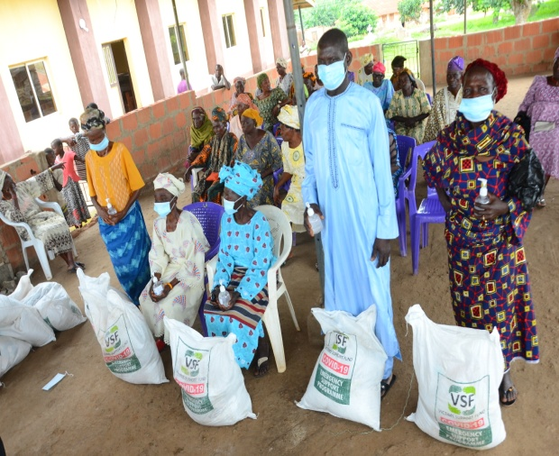
All the beneficiaries interviewed expressed their gratitude and appreciation to VSF. They confirmed that the palliatives are a form of miracle to them, an answer to a long prayer. Being a community lacking any social support, the beneficiaries said the palliatives will go a long way to meeting their needs and also extend same to households in the neighborhood. A beneficiary Mr. A. Ajayi said the palliative will relieve him haven just injured his left leg in an attempt to provide for his family. In his words, he said he has never seen a palliative as heavy as this, and that he can’t wait to open the content.
Figure 6: A beneficiary A.Ajayi appreciating the efforts of VSF

FINDINGS/OBSERVATIONS:
The exercise revealed clearly that poverty continues to be the major problem of Nigeria and that urgent actions needed to be carried out by all stakeholders to address the menace. Some beneficiaries expressed the deepening disconnection between the people and government, they advised government to learn from the approach deployed by VSF and NISD in this process for her social support programs where everything is purely on merit and completely apolitical. Also, it came out very clearly that there is need for government to open up the farms within the rural settlements and ensure that buying centers are established, this will reduce wastage of agricultural produce, reduce rural dwellers dependence on big towns economies and ultimately reduce poverty.

RECOMMENDATIONS:
NISD strongly recommends that government at all level must continue to prioritize the needs of her people (social and economical). Also it became imperative that the social intervention programs of government must be detailed enough to accommodate all the social economic concerns of the people and also extend to all and sundry irrespective of citizens class and political affiliations. NISD also recommends that there is need to widen the social register of the state as our definition of poverty is being challenged by happenings from the streets/rural places as poverty might not necessarily reside in the rural places but also in big towns. NISD’s sustained engagement with VSF is also solicited, being an organization who has consistently worked with women groups for years, NISD could authoritatively speak on the social economic impacts of COVID-19 on women who are often the most hit and the most affected. It is also recommended that government set aside funds for emergency as the case of COVID-19

ANNEX:
Attached are some of pictures taken and short videos of beneficiaries interviewed.

